**Random controller:**

First we need to record the test we are done using Blaze meter or by setting proxy we can done.

After recording the tests we can download those recordings with extensions as .jmx,iand the recording will download and show in downloadings.

Now open jmeter and browse the location and open the recording in JMeter,Now right click on thread and create –add-logic controller-Random controller.

We can copy paste the tests as we needed.

And the tests added in the random controller will execute random one script.

.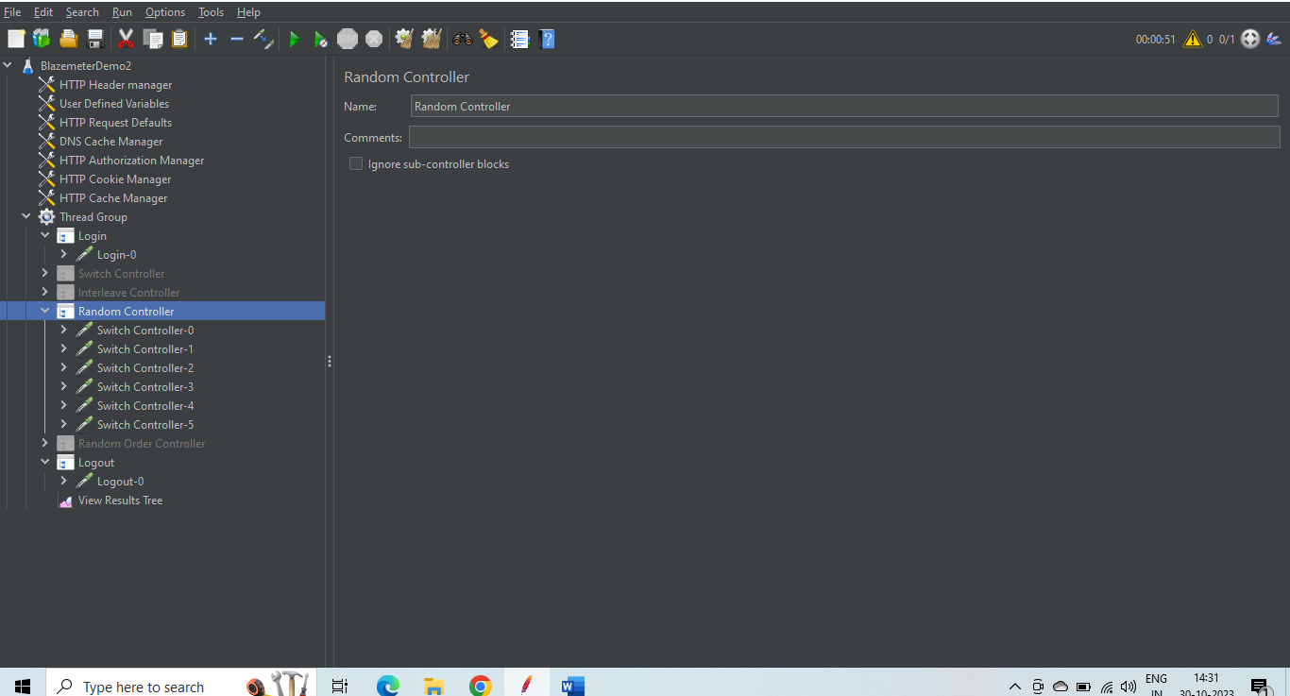

We can see the execution as given below can see one random test executed.

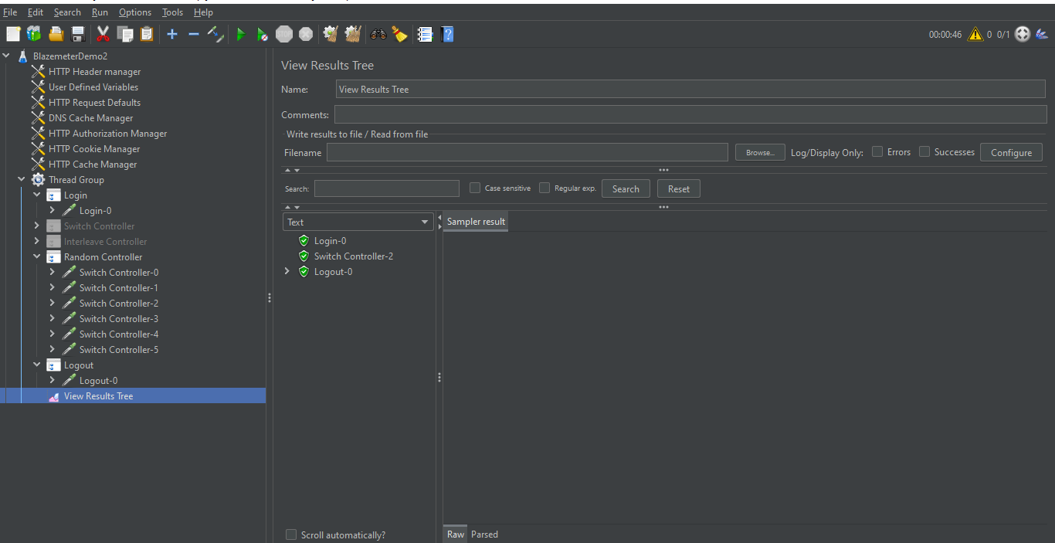

We can see above that the random test is exected from the tests present in the Random controller.